**Experiment no:06**

Experiment name**:** **Implementation of OSPF (open shortest path first) Algorithm**

Objectives: To determine the best route to a destination.

Equipment:

*Cisco packet tracer

*Windows OS

Theory:

OSPF is a routing protocol for IP. It is a link-state protocol, as opposed to a distance-vector protocol. A link-state protocol makes its routing decisions based on the states of the links that connect source and destination machines. The state of the link is a description of that interface and its relationship to its neighboring networking devices. The interface information includes the IP address of the interface, network mask, and type of network to which it is connected, routers connected to that network, and so on.

The OSPF network is composed of ABRs, ASBRs, and interior routers which are routers connected to multiple areas, and Autonomous System Boundary Routers (ASBRs). At a minimum, OSPF-based routers or access servers can be configured with all default parameter values, no authentication, and interfaces assigned to areas. If you intend to customize your environment, you must ensure coordinated configurations of all routers.

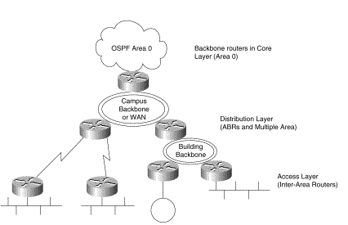

Fig: OSPF hierarchical topology

Working procedure:

*First of all we will open cisco packet tracer, then from the bottom toolbar ,we take generic pcs and routers. For this experiment we have taken 3 pcs and 3 router to design our network

*Then configure the PC 0,PC1, PC 1 with ip address with default gatway just like above :For PC 0-

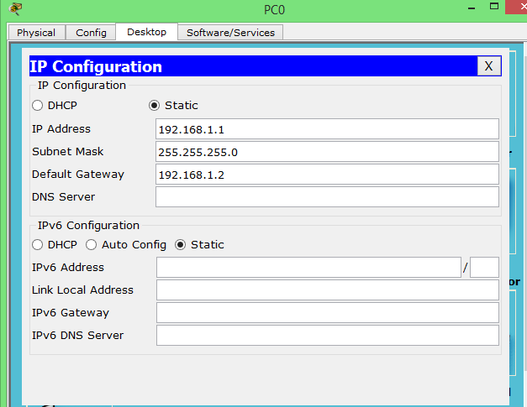

*Secondly, connect the pcs with wires and configure the corresponding routers using command line interface(CLI) following like: For PC0 ,

outer>en

Router#conf t

Enter configuration commands, one per line. End with CNTL/Z.

Router(config)#int fa 0/0

Router(config-if)#ip add 192.168.1.2 255.255.255.0

Router(config-if)#no shut

The changes will be like this

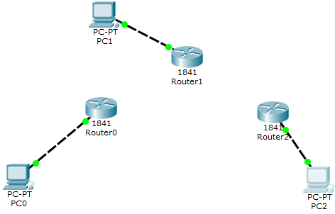

*Thirdly we establish a connection between routers using serial DCE and configure the routers with following command. For router 0-

Router(config-if)#exit

Router(config)#interface serial 0/1/1

Router(config-if)#ip add 192.168.8.2 255.255.255.0

Router(config-if)#clock rate 64000

Router(config-if)#no shut

%LINK-5-CHANGED: Interface Serial0/1/1, changed state to down

Router(config-if)#exit

Router(config)#interface serial 0/1/0

Router(config-if)#ip add 192.168.6.1 255.255.255.0

Router(config-if)#no shut

%LINK-5-CHANGED: Interface Serial0/1/0, changed state to down

Router(config-if)#exit

Router(config)#exit

Router#

%SYS-5-CONFIG_I: Configured from console by console

Router#conf t

Enter configuration commands, one per line. End with CNTL/Z.

Router(config)#router ospf 1

Router(config-router)#network 192.168.1.0 0.0.0.255 area 0

Router(config-router)#network 192.168.6.0 0.0.0.255 area 0

Router(config-router)#network 192.168.8.0 0.0.0.255 area 0

Router(config-router)#

%LINK-5-CHANGED: Interface Serial0/1/0, changed state to up

%LINEPROTO-5-UPDOWN: Line protocol on Interface Serial0/1/0, changed state to up

*we wil configure the all routers in the similar ways with similar ways.

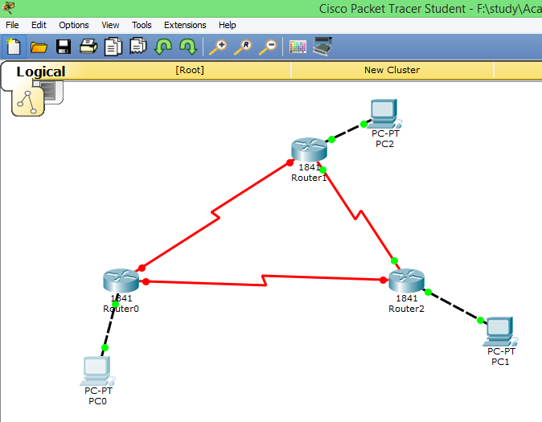

*Then we go to the simulation mode from the real mode and put message/packet to the source machine and select a destination. The Packet will be transferred using the optimum route. We send packet from pc 2 to pc 1.

*If its falied or stop then please check the configuration or where errors have occurred or may be overloaded.

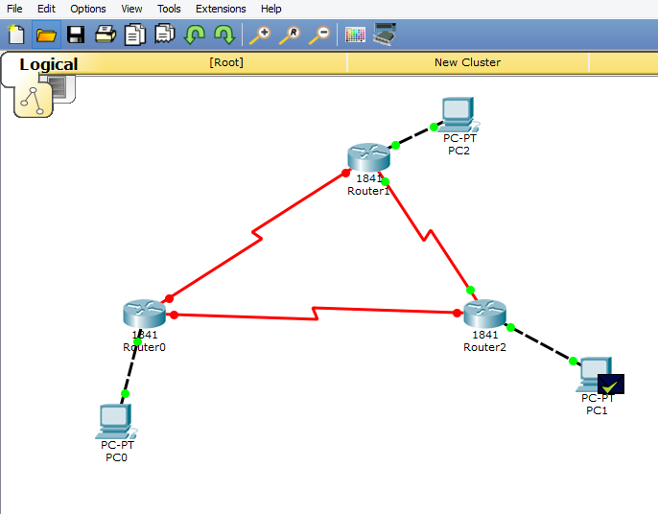

Conclusion:

Unlike Routing Information Protocol (RIP), OSPF does not provide periodic routing updates. On becoming neighbors, OSPF routers establish an adjacency by exchanging and synchronizing their databases. After that only changed routing information is propagated. Every router in an area advertises the costs and states of its  
links, sending this information in an LSA. This state information is sent to all OSPF neighbors one hop away. All the OSPF neighbors, in turn, send the state information unchanged. This flooding process continues until all devices in the area have the same link-state database.